1. Find tension given known weight suspended by 2 cords
2. Find tension given cart on ramp
3. Given known weight and two symmetric wires with known tension, find angle
4. 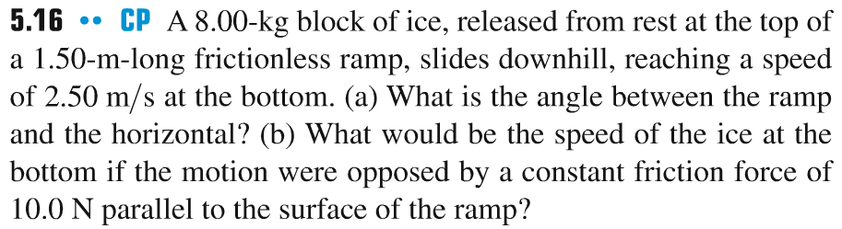
5. What is acceleration given known mass and scale
6. Ball on rope resting against wall